Production license no. : no. 20160011 liaoning food and drug administration machinery production license
Registration certificate no. : liaoning ordnance injection precision 20162570170
Technical document no. : liaoning ordnance injection precision 20162570170
Specification and model: HG type
Date of production;XX day, XX month, 20XX
The period of validity.6 years
Revision date;September 22, 2016

Endoscope automatic cleaning machine

make
with
said
Ming
book

Registrant/manufacturer; Shen Yang hongguang medical equipment co. LTD
Orders to record
1.Scope of application----------------------------------(2)
2.Of----------------------------------------------------(2)
3.Instructions------------------------------------------(2)
4.Technical performance---------------------------------(5)
5.Installation------------------------------------------(5)
6.Instructions------------------------------------------(6)
7.Fault management--------------------------------------(12)
8.Notes-------------------------------------------------(13)
9.Warning(10) ------------------------------------------(14)
10.Maintenance(10) -------------------------------------(15)
11.Storage and transportation conditions----------------(15)
12.Replacement requirements for loss parts--------------(15)
13.Part list--------------------------------------------(15)
14.Objects used by the product--------------------------(16)
15.Potential safety hazards and use restrictions--------(16)
16.Accidental disposal occurs in the correct use--------(17)
17.Interference with other products---------------------(17)
18.Disposal of waste------------------------------------(17)
19.Precautions for feature operation--------------------(17)
20.Monitoring and control-------------------------------(17)

1.Scope of application
Suitable for cleaning and disinfection of endoscope.
2.Of
The washing machine consists of acid oxidizing potential water generator, salt pool, washing tank, load rack, washing pump, air pump, pipeline, valve, control system and shell.
3.Instructions
Scope of application: suitable for cleaning and disinfection of endoscope
The automatic cleaning and elimination machine of endoscope has the following characteristics:
1.Before using this machine, please clean the endoscope by hand.
2.This machine specially designed the horizontal structure according to the structural characteristics of the endoscope, so that the endoscope was coiled in the cleaning and disinfection warehouse and washed flat.
3.The product is equipped with an automatic acid oxidation potential water generation system, which is sterilized by the acid oxidation potential water generated by the system.
4.The automatic water exchange system ensures that new water is replaced at each cleaning stage, and standardized water cleaning and disinfection is carried out to avoid cross infection.
5.Use rotating high pressure spray arm to wash the surface and inner cavity of the endoscope directly.
6.The control system of this machine adopts automatic control.Avoid the wear and tear of equipment caused by repeated keys.
7.Disinfectant temperature requirements;The machine built-in acid oxidation potential water generator, the generated disinfectant between ﹢ 5 °, 45 °, can reach the standard disinfection liquid state, can meet various areas in the condition of room temperature can be used.
8.The machine clean water for the machine built-in acid oxidation potential water generator to generate alkaline water (washing water), self generated alkaline water ﹢ between 5 °, 45 °, can reach the standard cleaning liquid condition.
9.The total number of bacteria in rinsing water is less than xx10CFU/100ML
10.Each phase of the machine operating temperature should be between the ﹢ 5 °, 45 °, above or below + 5 ℃ with alarm prompt.
11.Quantitative systems;The container holding the chemical liquid has a capacity of 3.1 liters.
12.The electromagnetic compatibility of this machine meets the requirements of GB/ t18268.1-2010 standard.
13.The maximum pressure of each pipe in the machine at design time is;0.4mpa, maximum velocity; 500 milliliters per second, minimum velocity;15 milliliters per second.
14.The product is equipped with an acid oxidation potential water generator, which produces acid oxidation potential water for disinfection. The specific principle is as follows:
The pH value of the living environment of bacteria, viruses, fungi and other microbes is between 4-9, and the ORP is between -400mv and +900mv. Outside this range, microbes struggle to survive and reproduce. ORP determines the respiration metabolism of microorganisms. The sterilization mechanism of acidic oxidizing potential water is to change the living environment of microorganisms by using its high REDOX potential (ORP > 1100mv) and low pH value (pH < 2.7), so as to change the membrane potential of microorganisms, leading to increased membrane permeability and destruction of cell metabolic enzymes, thus killing microorganisms. The results showed that the cell membrane of staphylococcus aureus was swollen and ruptured immediately after the treatment of acidic oxidative potential water under the electron microscope. The black bacillus subtilis cells were treated with acidic oxidative potential water for 20 minutes, and their medulla was swollen, the outer shell was broken, and the internal solute was spilt, and the killing effect was achieved.
4.Technical performance:
The rated voltage | 50 hz, 220 v | Sterilization time | Min 1-99.
Effective chlorine content | 80 mg/L or higher | Water consumption | 9 l
Rated current | 10 a | Cleaning method | High pressure spray
Rated power | 2000 w or less | Water making time | 1-9 min
Use the water pressure | 0.02-0.02 Mpa | Yuexiang capacity | 12 l
Acid water pH | 3.0 or less | ORP value | 1100 mv
5.Installation
1.Structure name
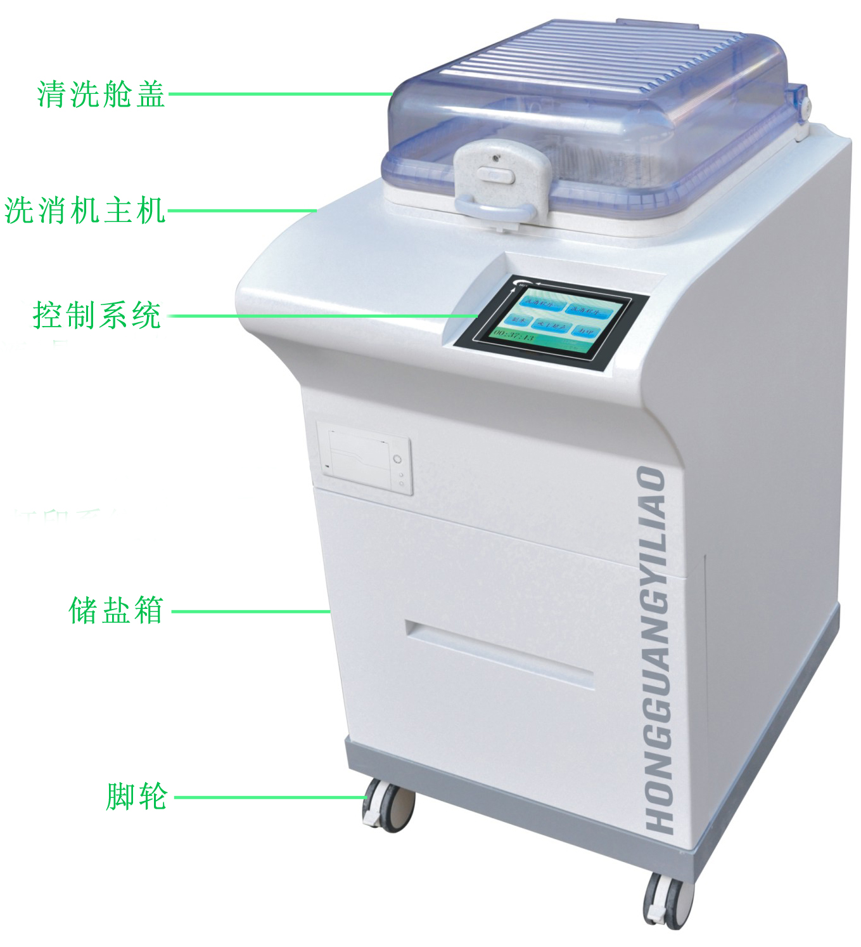

2.Installation instructions
2.1 connect the upper and lower water pipes.
2.2 connect one end of the drain pipe to the water outlet and the other end to the water outlet on the equipment.
2.3 connect the special faucet to the water inlet pipe.
2.4 connect one end of the inlet pipe to the special faucet and the other end to the equipment inlet.
2.5 one end of the power cord is connected to the power socket of the box body, and the other end is connected to the power supply of the network.
6.Instructions
1.The minimum sterilization time of the machine in the treatment of endoscope is 20 minutes.
2.Preparation
2.1 turn on the tap.
2.2 150g NaCl was measured with a measuring tube and 1000 ml water was added to make a saturated NaCl solution.Put the salt suction pipe into the salt storage tank and cover the salt storage tank.Add the cleaning solution to the cleaning solution box.
2.3 open the top cover of the washer and gently coil all the endoscopes into the cleaning bin. For some equipment components (such as point joints) that cannot invade water or water solution as specified by the endoscope manufacturer, they shall be handled according to the manufacturer's instructions. These components shall not be immersed in the endoscope automatic cleaning and disinfection machine when processed.
2.4 place the operating part of the endoscope on the endoscope shelf of the supporting frame.
2.5 cover tightly and clean the hatchcover to close the door control switch.Cleaning the uncovered equipment will alarm, sound the alarm and the machine will not work.
2.6 connect the silicone tube labeled "inside pipe washing" on the equipment to the inner pipe of the endoscope for inside pipe washing.
2.7 turn on the power switch.
2.8 press the irrigation button to perform the irrigation on the endoscopic pipelines.
3.Operation instructions
3.1 touch screen calibration: press and hold the touch screen before starting up, and click the white cross on the screen (twice) after starting up to complete the calibration.(the equipment has been calibrated before it leaves the factory, no recalibration is required)
3.2 enter the standby interface:
3.3 when the new equipment is used for the first time, the water making step shall be carried out first. Click the "water making" button on the touch screen, where the water making time is adjustable from 1 to 9min (the factory default is set to 5min), the step length is 1min, and the water inlet time is adjustable from 1sec to 99sec (the factory has been set to 88sec).The resulting acid oxidizing potential water has a REDOX potential of more than 1100mV and a pH value of alkaline oxidizing potential water of no less than 9.ORP values can be adjusted by adjusting the time of entering the saturated brine if sufficient brine is ensured.Press the "start" button to start the electrolysis. After the electrolysis, the buzzer will alarm and return to the main interface automatically. Then the first cleaning and disinfection of the endoscope can be carried out.
Note;Our company shall not take any responsibility for any damage caused by the customer's adjusting the time of salt water intake to the relevant equipment during the use of this machine.
3.4 program selection;This machine sets up two sets of washing and elimination procedures
3.4.1 adjustable cleaning.(cleansing procedure 1)
Press the "decontamination procedure a" key, into the cleaning fluid time 1-30 s adjustable, adjustable washing time 1 to 30 min, medicine washing disinfection time for 1-99 min is adjustable, cleaning (alkaline) 1-9 min time is adjustable, rinse time 1 min is not adjustable, cleaning and disinfection of the operators according to the specific conditions of setting up time, press the start button, a decontamination procedures work at the beginning, order, according to "into the water", "wash", "water", "into the disinfection solution", "liquid disinfection wash", "line of disinfection liquid medicine", "water", "clean", "water", "into the water", "full","Drain".
Note: at the same time of disinfection and rinsing, the water making process starts, automatically enters the water and electrolyzes the disinfectant for the next use.
3.4.2 fixed cleaning.(cleansing procedure 2)
Press the "washing and disinfection program 2" button, and the cleaning and disinfection time of washing and disinfection program 2 is fixed. The rinsing time is 3min, the rinsing time of disinfection and disinfection of pharmaceutical liquid is 20min, and the cleaning time is 1min.The rinsing time is 1min, and the display of cleaning and disinfection process of washout program 2 is the same as that of rinsing program 1.
3.4.3 disinfection method;Built-in acid oxidation potential water generation system, this machine generates its own disinfectant, [acid oxidation potential water] disinfectant row by row without repeated use, the PH and effective chlorine concentration of acid oxidation potential water should be measured every time it is used.
3.4.4 the machine is equipped with a water filter. The filter core of the filter is 0.2-dringham, which should be replaced once every 3-6 months according to different water quality.
3.4.5 the machine is equipped with an acid oxidizing potential water generation system, which can generate disinfectant by itself. [acidic oxidizing potential water (disinfectant water replaces disinfectant) and alkaline water (cleaning water replaces cleaning liquid)]. Both acid oxidizing potential water and alkaline water are used at room temperature.
3.5 drying of endoscope
Connect the endoscopic biopsy pipe and the water and gas pipeline with the blow-dry pipe, put the endoscope and the cleaning cabin, cover the hatch cover, press the "blow-dry self-elimination" button, and press the start button after entering the interface to adjust the blow-dry time.
After the adjustment, press the start button and the device starts to work.
The drying process shall be carried out in accordance with the requirements of the device and device pipe manufacturer before storage.
3.6 equipment cleaning.
(1) clean all the residues in the tank onto the filter, and then take out the filter for cleaning.
(2) clean the inside of the hatchcover and spray tank with a clean soft cloth.
3.7 procedures and procedures shall be maintained
During the execution of the program, if the power is suddenly cut off, the device will temporarily save the execution steps of the current program.When you call again, the device prompts you to continue with the last uncompleted program.Click "yes" to continue the washing, and click "no" to return to the main interface.
3.8 self-sterilization
In the case of no-load machine, press the "blow-dry self-elimination" button, and after entering the interface, adjust the "blow-dry time" to "0" and press the start button. According to the instructions of the program, the equipment will disinfect the pipe, sterilization bin, sink, cavity and nozzle of the machine and other parts.(due to equipment maintenance, test interruption, long - term equipment does not need to run this program).
The machine disinfects the cleaning bin, stainless steel bracket, cleaning cover, irrigation pipeline, irrigation joint and liquid operation pipeline when its own disinfection program is started.
The parts treated by the self-sterilization of the machine do not include water treatment equipment.
3.9 date and time Settings
LCD screen time setting. Click the time position below the main interface to display as shown in figure 1. Press the left and right keys to adjust the time. Complete the time setting.
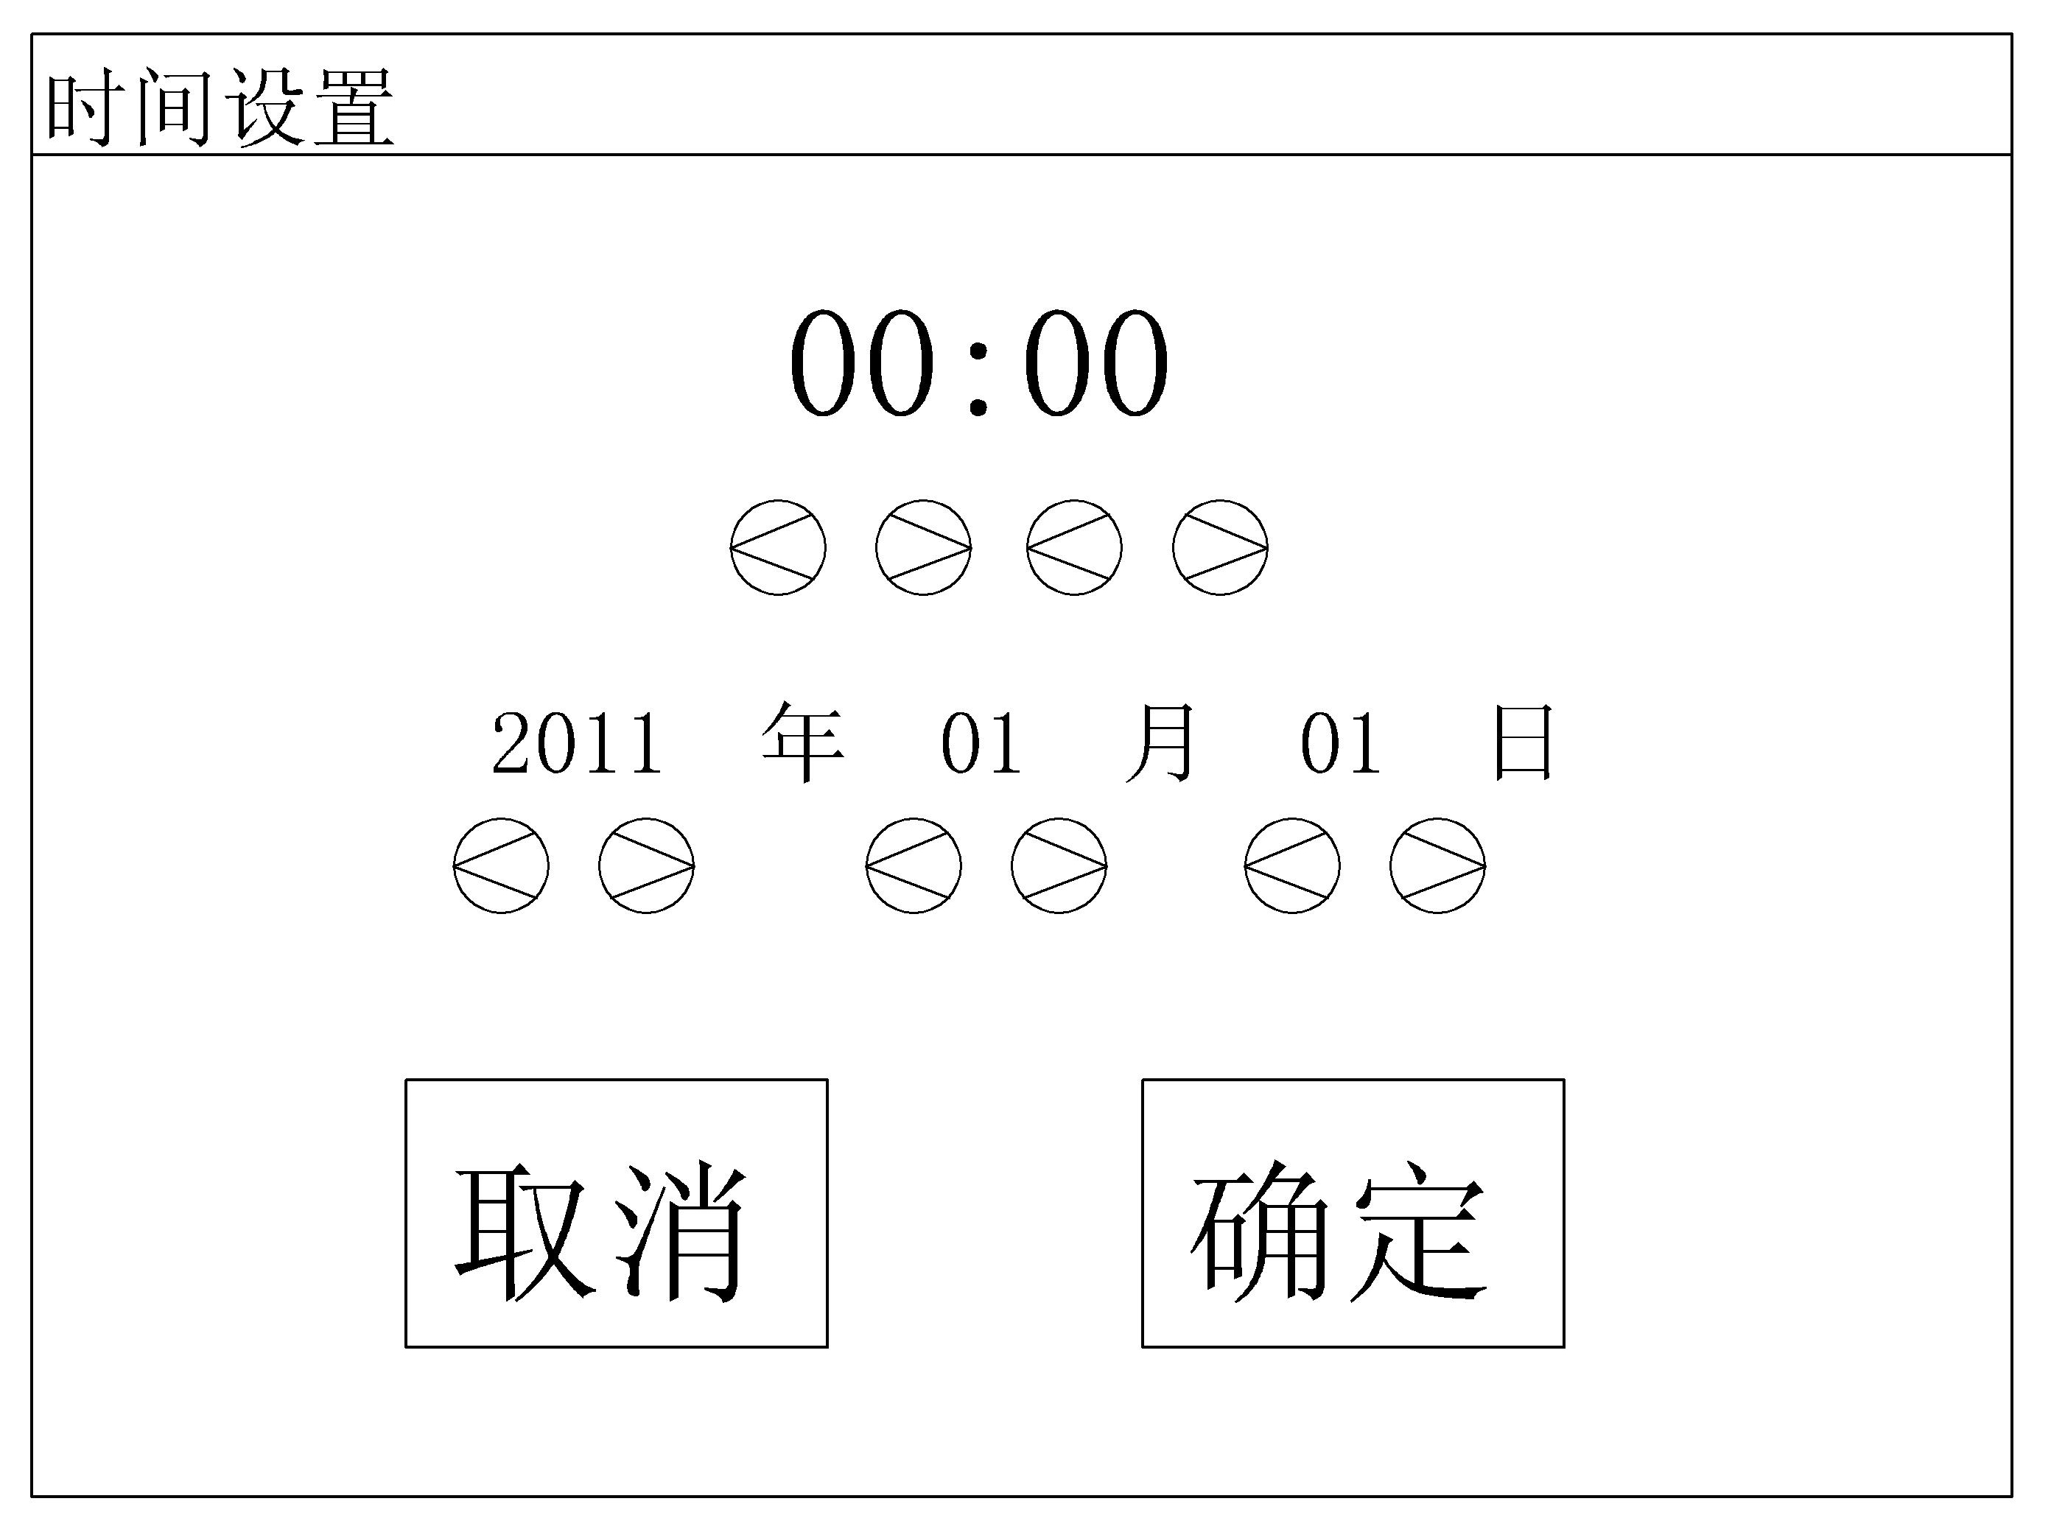
Figure 1
7.Fault handling

The fault | why | Ruled out measures
Can't start | 1.The roof is not strict  2.The touch screen is not calibrated | 1.Lock the top cover tightly to close the switch  2.Calibrate the touch screen
Liquid crystal screen is not bright | 1.The power is not connected  2. The fuse is broken | 1.Power on  Change the fuse
Don't feed water | 1.The water source is not opened  2.The inlet solenoid valve is damaged | 1.Open water source  2.Check or replace the solenoid valve
leaking | 1.Loose pipe connection  2.Pipeline fracture | 1.Check the pipeline and connect it  2. Replace the pipeline
The spray arm is not working properly | 1.Insufficient water level  2.Siphon phenomenon | 1.Adjust the water level control port  2.Remove excess water from drain pipes
ORP value is not enough | 1.Aging of electrode plate  2.Electrolytic membrane aging | 1.change  2.cleaning
ORP value is too high | 1.Repeated electrolysis  2.Excessive NaC1 | 1.Discharge and re-electrolysis  2.Reduce NaC1 equivalent
8.Notes
1.Please do not open the top cover during cleaning to avoid liquid leakage.
2.The endoscopes put in should not be folded together. Gaps should be set aside for thorough disinfection.
3.If the local water does not meet the national drinking water standard, after cleaning, use 75% medical alcohol to scrub the outer wall and lens of the endoscope.
4.The machine must be set in a safe and stable place;
5.Smooth placing of inlet and outlet hoses. Do not place objects or bend and knot on hoses;
6.The spray arm rotates flexibly and no objects are allowed to block it;
7.Do not scratch the LCD screen with sharp objects.
8.Before each use of this machine, PH value and effective chlorine content were respectively measured by PH test paper and effective chlorine test paper at the outlet of on-site acidic oxidizing potential water.
9.The pressure and flow rates used in the treatment of the device shall not exceed the pressure and flow rates specified by the manufacturer of the medical device being treated.
10.After two years of use, or 5,000 patients (whichever method of calculation is the first to reach that one) must replace the ionic membrane.
9.The warning
1.The network power supply of the device must be well grounded.
2.Do not replace non-factory original parts, especially active parts.
3.Cover and clean the hatchcover before starting the equipment.
4.The L and N sockets of the network power must be checked before switching on the power supply of the device.
5.Our company shall not be responsible for any damage caused by the self-adjustment of the time of salt water intake.
6.This article shell for synthetic plastics, do not come in contact with the liquid or object of more than 70 °.
7.Adverse events that may result from the use of the product or ingredients in the product that may cause side effects have not been found.
10.Maintenance
1.Clean the salt storage tank once a week.
2.75% alcohol should be used to clean the disinfecting warehouse after the end of the whole work.
3.The filter element of the water purifier should be replaced every six months.
11.Storage and transportation conditions
Storage and transportation conditions
1.Working conditions: temperature: 0-50c \ humidity: 15-90%
2.Storage conditions: -20-60c \ humidity: 15-90%
3.Mode of transport; Steam and railway
12.Provisions for replacement of worn parts
1.The electrolytic film is changed every 18-24 months
2.The electrolytic electrode plate is replaced every 18-24 months
3.The filter element of water purifier is changed every 6 months
13.Parts list
1.One inlet pipe.
2.One drain pipe.
3.One overflow pipe
4.The inner pipe has three channels of irrigation and one channel of irrigation.
5.One set of measuring cups.
6.One blowpipe.
7.Hang one handle.
8.Four fuses.
14.Objects used by the product： A medical institution
15.Potential safety hazards and use restrictions
1.The drain pipe provided by the customer must be more than 50mm in diameter, and the water entering into the water shall conform to the provisions of GB5749.
2.For the connection requirements of power cord, the power plug of this equipment is three-core wire, and the L and N on the three-core wire should be connected to L and N on the power socket. The ground wire should be grounded. If there is no ground wire in the power socket, a ground wire must be installed to avoid power leakage accidents.
3.The maximum pressure of each pipe in the machine at design time is; 0.4mpa, maximum velocity; 500 milliliters per second, minimum velocity; 15 milliliters per second.
4.The pressure and flow rate used in the treatment of the device shall not exceed the pressure and flow rate specified by the manufacturer of the medical device being treated.
16.Accidental handling occurs during proper use
1.In case of any accident during the correct use of the product, the water and power shall be immediately turned off.Call the after-sales service phone immediately, and don't use the equipment until the failure is completely eliminated.
17.Interference with other products
1.Meet the relevant requirements of EMC18268.1 standard.
2.Keep a safe distance from electromagnetic sensitive equipment such as electrocardiograph to avoid interference
3.The static electricity and voltage drop beyond the standard may cause the LCD to blink.
18.Disposal of waste
1.When the equipment is disposed of, the circuit system can be treated as normal waste, and the cleaning tank, pipeline and link parts should be treated as medical waste.
19.Precautions for feature operation
1.The machine case and cleaning room of this product are made of plastic material, which is not easy to contact with high-temperature materials.
20.Monitoring and control
1.When the device is powered on, the LCD screen will automatically jump into the working status monitoring display after the switch is turned on.
2.Before each use, PH and valid chlorine test paper were used to measure the concentration at the outlet of on-site acidic oxidizing potential water.

Please read this manual carefully before you start using it

After-sales service
Shen Yang hongguang medical equipment co. LTD
No. 121-3, huigong street, shenhe district, shenyang city
Telephone: 024-86119030
Registrant/manufacturer;Shen Yang hongguang medical equipment co. LTD
The domicile of the registrant;No.1 coal kilometer, yingpan road, dongling district, shenyang
The address of the registrant;No. 121-3, huigong street, shenhe district, shenyang city
Domicile of the manufacturer;No.1 coal kilometer, yingpan road, dongling district, shenyang
Manufacturer's manufacturing address;No. 121-3, huigong street, shenhe district, shenyang city
Telephone: 024-86119030
Fax: 024-86119479
Zip code: 110031
Email address: hongguangyiliao@126.com
mailto:hongguangyiliao@126.com
Website: www.syhongguangyiliao.com

